**LPG Supply Chain**

The chart above depicts a simplified isometric chart of the assumed supply chain management for ABSA refineries.

We can understand it in the form of steps from start to end

Production -

Crude oil is obtained through the process of drilling deep wells. After extraction, the crude oil is transferred to refineries, which are large-scale facilities that separate several products from the crude oil, including gasoline, diesel fuel, and heating oil.

Port of Sale -

The port of sale is the last destination of the production part, where the oil is discharged and ownership is officially transferred.

Consider it as a refueling station for substantial oil deliveries. The seller transports the oil to the port, at which point the buyer assumes ownership and accountability for it.

Transportation -

Oil transportation plays a vital role in the oil and gas supply chain, facilitating the movement of crude oil from extraction sites to refineries and delivering refined products to end users. Below is an analysis of the formal elements and how the names of the tankers that are provided connect with them:

Modes of transportation:

Sea Shipment: This is the primary method for transporting oil worldwide, using big tankers of different capacities. Some examples of tankers are Gudrun, Pretty World, and Ismini, which had been mentioned.

Pipelines provide a cost-efficient and uninterrupted transportation method for oil across extensive distances, especially for refineries located in areas without access to the sea or for delivering oil within a certain geographical area.

Classification of Tankers:

Tankers are classified according to their Deadweight Tonnage (DWT), which refers to the maximum weight of cargo, specifically oil, that they are capable of carrying. Below is an analysis of some typical tanker classifications:

Very Large Crude Carriers (VLCC) are the largest tankers, with a Deadweight Tonnage (DWT) that surpasses 200,000 tons. They are well-suited for conveying substantial quantities of unrefined petroleum over extensive distances, such as Gudrun.

Aframax tankers are classified as medium-sized vessels with a deadweight tonnage (DWT) ranging from 80,000 to 120,000 tons. They provide versatility for different routes and ports, and Ismini may potentially fall into this category.

**Basic Model**

This is a model we did in Python which IBM Decision Optimization CPLEX Modelling from the docplex library. To start with the model, we first import the libraries required for us to run the model.

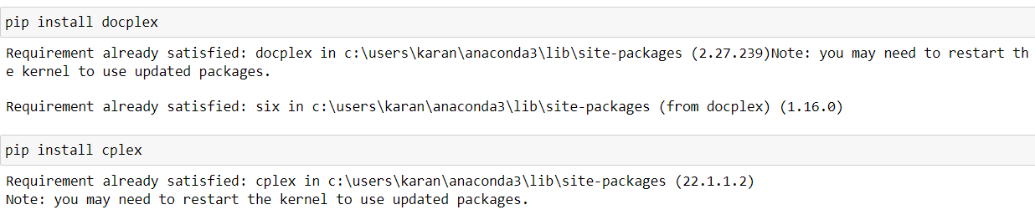

The document has various variables to be defined at first which can be listed below-

1. **Costs**: Details on the expenses incurred in processing crude oil and the cost of purchasing different types of crude oil.
2. **Prices**: The selling prices of various products derived from crude oil.
3. **Capacities**: Maximum production limits at each refinery location, providing insight into the scale of operations.
4. **Monthly Supply Quotas**: Limits on how much of each type of crude oil can be purchased in a month, ensuring balanced procurement.
5. **Demands**: Quantifies the demand for each product across different regions, indicating market needs.

Our project's objective is to put this data to create an approach which will optimize profit while supplying demand, sustaining capacity for production, and upholding purchasing limits. Making judgements involve calculating exactly the most appropriate quantities of crude oil to purchase and the amount of each product each refinery can generate.

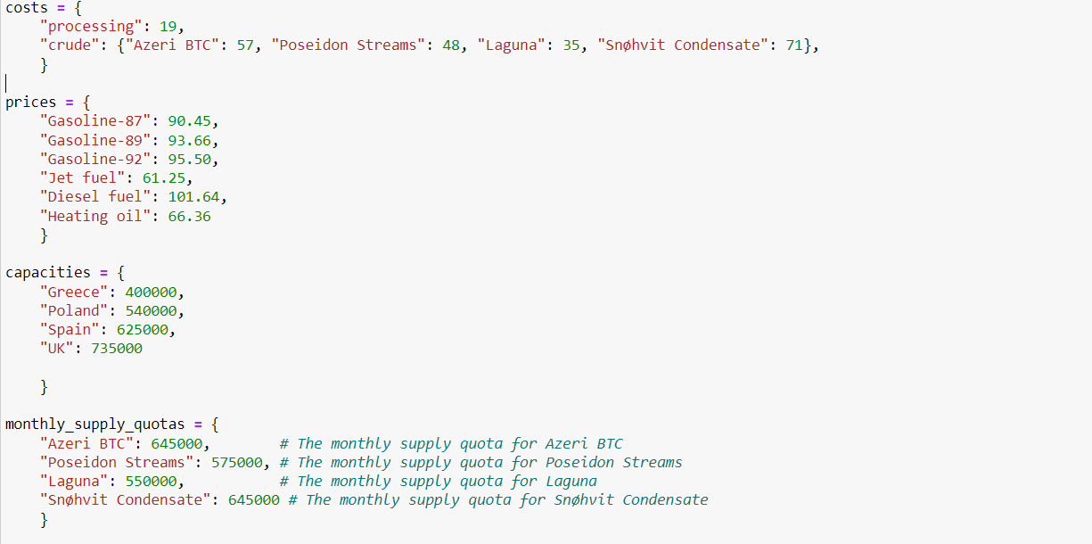

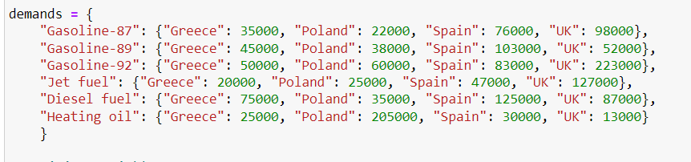

Our purchase and manufacturing approaches to crude oil products are heavily influenced by the selection variables in our optimisation model. The first collection of variables are the purchase variables, which represent the different quantities of crude oil forms we are able to purchase. Since these variables are adaptable, we can change our purchasing approach depending on to demand and cost considerations. Then there is the production variable, which shows us how much we may produce at every refinery location of each product. Considering them to be our levers of modifying production to limitations in capacity and market demand.



Our guiding principle in our optimization model is to maximize profit, which can be expressed by the objective function. For this, we took into account a number of factors. First, we multiply the cost of each product by the number of units that is produced at each refinery to figure out the revenue which generates from exporting it. This gives us with a projection of the profits from sales. We next calculate for all the associated costs. We estimate the total expense of purchasing crude oil through multiplying the amount purchased by the cost per unit of each type of crude oil. In addition, we multiply the processing cost per unit by the production volume to figure out the cost of production spent at every refinery.



Now, we defined the constraints for our model which can be explained below-

1. We made sure that each product's production either meets or exceeds local demand. It also means that each product should be produced in sufficient amounts in each region to satisfy the demand that is specific to that region.
2. We make sure that no refinery's output exceeds its capacity. We can't afford to overburden any refinery beyond what is technically reasonable under this constraint.
3. We enforce a 1:1 ratio among the cost of purchasing and consumption of crude oil. This ensures that the total quantity of crude oil used for all products and regions is equivalent to the quantity of crude oil purchased.
4. We meet every variety of crude oil's monthly supply quota. This limit ensures  that we avoid purchasing more crude oil than we must purchase each month so as to meet our set supply quota.

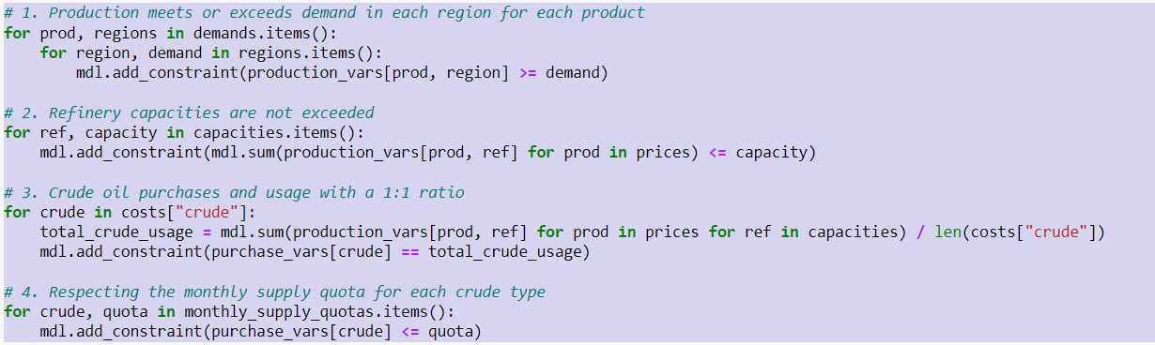

This part of code develops and resolves the optimization model, subsequently evaluates that a solution was found. It gets and prints the responses if there is an answer. The profit achieved is expressed by the objective value, that is shown. The quantity purchased is then printed for each type of oil that was purchased. It additionally displays the overall amount of every product generated at every refinery. The values provided show the ideal production and purchase schedule and are discovered by the optimization model. If, on the other hand, no viable solution is found, it merely produces a message to that extent. By this procedure, we are able to evaluate and understand the best choices given by the optimization model, providing insightful information for making decisions regarding the production and processing of oil.

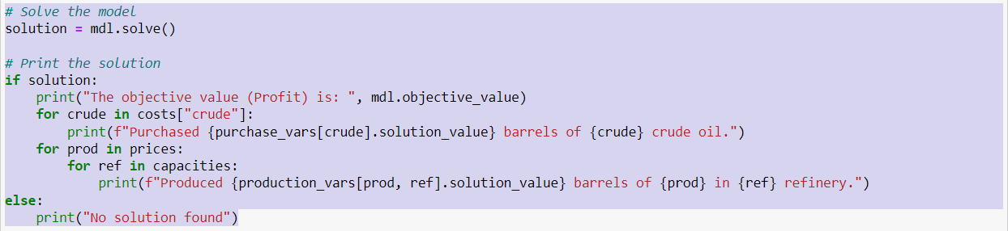

The output would be as follows-

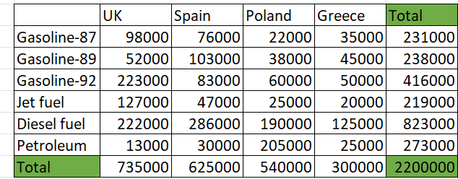

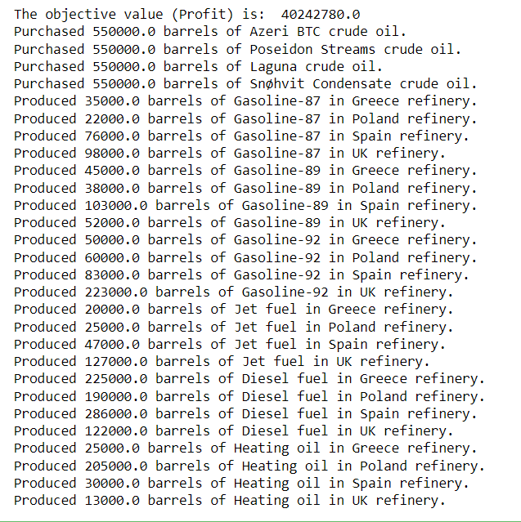

Output Analysis

An analysis of the refinery output reveals several interesting aspects. Firstly, refineries in the UK and Spain boast the highest production capacity, as evidenced by their maximum barrel output. From a profit perspective, diesel appears to be the most produced oil type, potentially signifying greater profitability, followed closely by Gasoline-92. Furthermore, three refineries are operating at full capacity, demonstrating efficient utilization of resources. However, Greece's production falls short of the maximum capacity by 100,000 barrels, suggesting underutilization or potential constraints. The absence of excess production also implies effective inventory management, as the 7% discount scenario wouldn't be applicable.